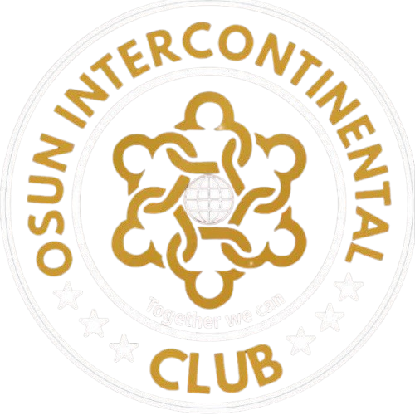 | OSUN INTERCONTINENTAL CLUB  Community Growth Through Connection  MOSAB Mega Hall, KM2, West Bye Pass, opposite NASFAT Prayer Centre, Ring Road, Osogbo, Osun State | info@osunintercontinentalclub.org

CONGRATULATORY MESSAGE
Osun Intercontinental Club Congratulates Professor Peter O. Olapegba on His Appointment as the 14th Vice-Chancellor of the University of Ibadan
23 July 2026
Interim Executive Committee  Abiola Moshood ABIOYE  President  Taofeek Gbolahan Muritala  Vice President  Alh. Adebayo AZEEZ  General Secretary  Engr. Kazeem Adebisi Lasisi  Asst. General Secretary  Ademiluyi Gbenga  Financial Secretary  Nasiru Oladele Ismaila  Treasurer  Tunde Busari  Publicity/Social Director  Taofik Ajisola Lamid  Legal Advisor  Rahman Owolafe Sikiru Olayinka  Chief Whip | On behalf of the Interim Executive Committee and the entire family of Osun Intercontinental Club, we extend our heartfelt congratulations to Professor Peter O. Olapegba on his appointment as the 14th substantive Vice-Chancellor of the University of Ibadan.  This appointment is a fitting recognition of your distinguished academic record, your decades of service to the University of Ibadan, and your respected contributions to scholarship, research, administration, and public service.  We recall with pride your thoughtful contribution as a guest speaker at our 4th Annual Colloquium and End-of-Year Party, where you delivered the paper titled, "Attaining Senior Citizens Age: Social Implications, Mental Health and Other Concerns." Your presentation reflected the clarity, humanity, and intellectual depth that continue to define your public work.  As you assume this historic responsibility, we pray for wisdom, strength, sound health, and uncommon success. May your tenure bring renewed progress to the University of Ibadan and enduring value to the wider academic community.  Congratulations, Professor Olapegba.  For and on behalf of Osun Intercontinental Club,  Interim Executive Committee

